Screen-Space God Rays in kbEngine

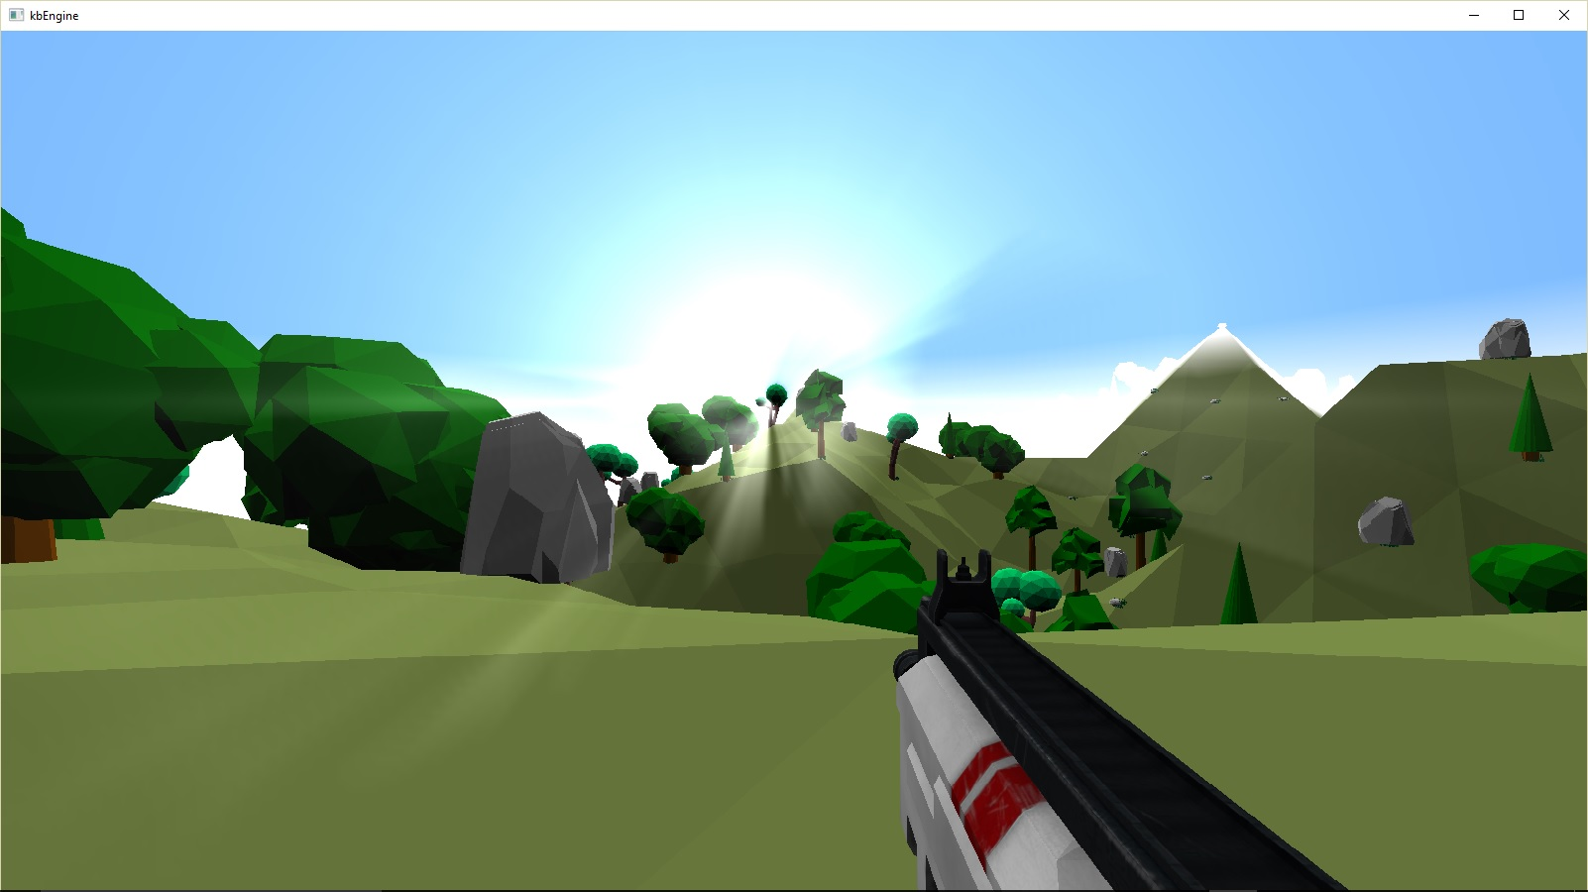

kbEngine supports Screen-Space God Rays which create the illusion that rays from the sun are blocked by objects in the world. They’re rendered as a post-process effect after the world geometry has filled the depth buffer. The high-level steps are:
- Create a masked flare texture
- Render the “flare-outs” by repeatedly scaling and rendering the masked texture into a low-res scene texture
- Draw the low-res scene texture back on top the full-sized color buffer.

Creating the masked flare texture
The engine allows the developer to specify a texture which serves as the base image. The screenshots here used a free lens flare texture from brusheezy.com ^{[1]} :

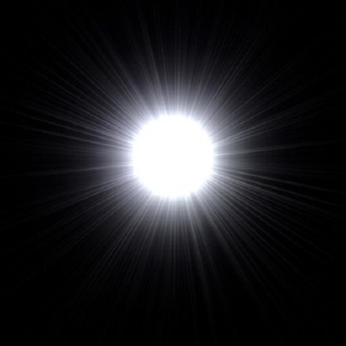

The masked flare texture is created by multiplying the user specified base texture with 1- sign(depthBufferPixel) and outputting the results into a render target:

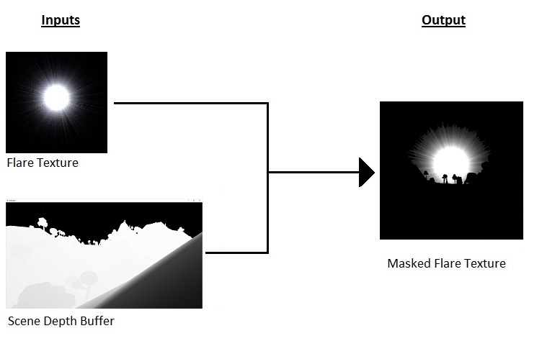

Creating the “flare outs”
The next step is to repeatedly scale and draw the masked flare texture into a low-res scene texture. This process makes the beams appear to cast out from behind objects:

Performance
Performance can certainly be an issue with this technique. Repeatedly drawing the masked flare texture results in a lot of overdraw. Performing the flaring iterations in a low-res scene texture can help achieve acceptable looking flares while maintaining performance goals. Using fewer iterations with wider step sizes can help too. However, this can lead to objectionable banding artifacts. A Gaussian blur can be applied to help smooth out the banding.

Another performance improvement is to combine several iterations by sampling the masked flare texture multiple times in each step. While the actual number of texel fetches may be the same, there will be fewer additive blends to the low-res scene texture.

Apply the flare out back to the scene
Finally, the low-res scene texture is added on top the scene color buffer to produce the final image:

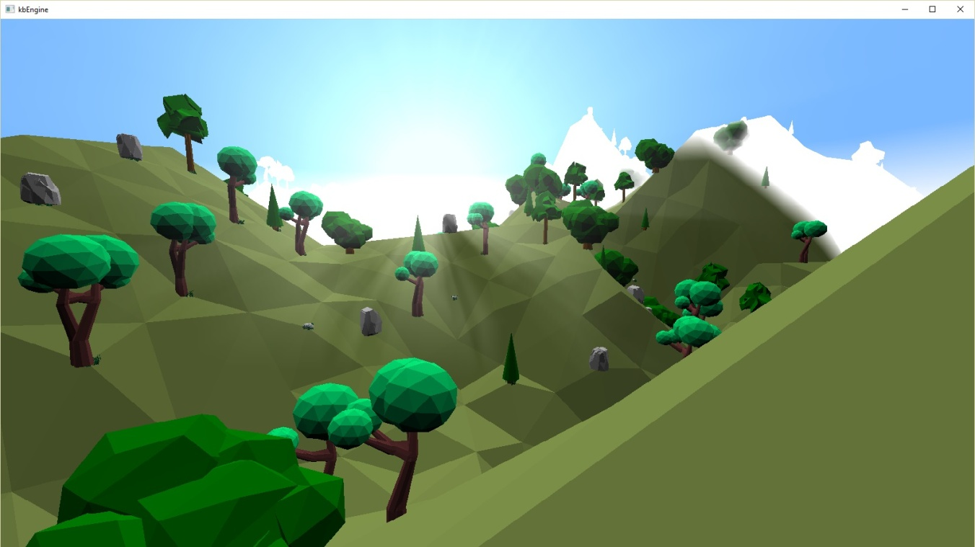

References
- “Lens Flare Textures by Brandondorf at Brusheezy”

